**Gas Volume Calculations**

When working with gases it is more common to use volume instead of mass.

**1 mole of any gas has a volume of 24dm3 or 24000cm3 at rtp (molar volume)**



We can use another triangle to relate moles, volume and molar volume.

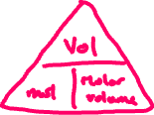

E.g. What is the volume of 0.5 mol of CO2 in dm3 at rtp?



E.g. How many moles would occupy 15000cm3 at rtp?



These questions are often related to reacting mass questions. E.g. What is the maximum volume of hydrogen that could be produced from 100g of zinc?



Zn + 2HCl 🡪 ZnCl2 + H2

